Programmer Mk 2
Keypad and display Unit

User Manual
Rev 1.10 (applies to firmware rev 1.08)
25.11.2003

DOCUMENT REVISION HISTORY

Revision | Date | Comments | Made By
1.10 | November 25th, 2003 | Updated to firmware functionality 1.08 | LBM
1.00 | August 13th, 2003 | Initial document | LBM
CONTENT

1 GENERAL 4
2 MAIN FEATURES 5
3 CONNECTING TO FLASHER 5
4 KEYS 6
5 PRINCIPLES OF PROGRAM 7
5.1 CONNECTING TO FLASHER 7
5.2 EDIT PARAMETERS 8
5.3 READING FROM THE FLASHER 9
5.4 SAVING SETTINGS TO FLASHER 10
5.5 EDITING FLASHING CHARACTERS 10
5.6 ILLUMINATION 13
6 FLASHER PARAMETERS 14
7 FLASHER READINGS 15
8 SPARE PARTS 16

GENERAL
The Programmer is a portable keypad and display unit has been developed for monitoring and programming the Sabik lantern controllers SmartFlasher 6-28 and LEDFlasher (available end 2003).

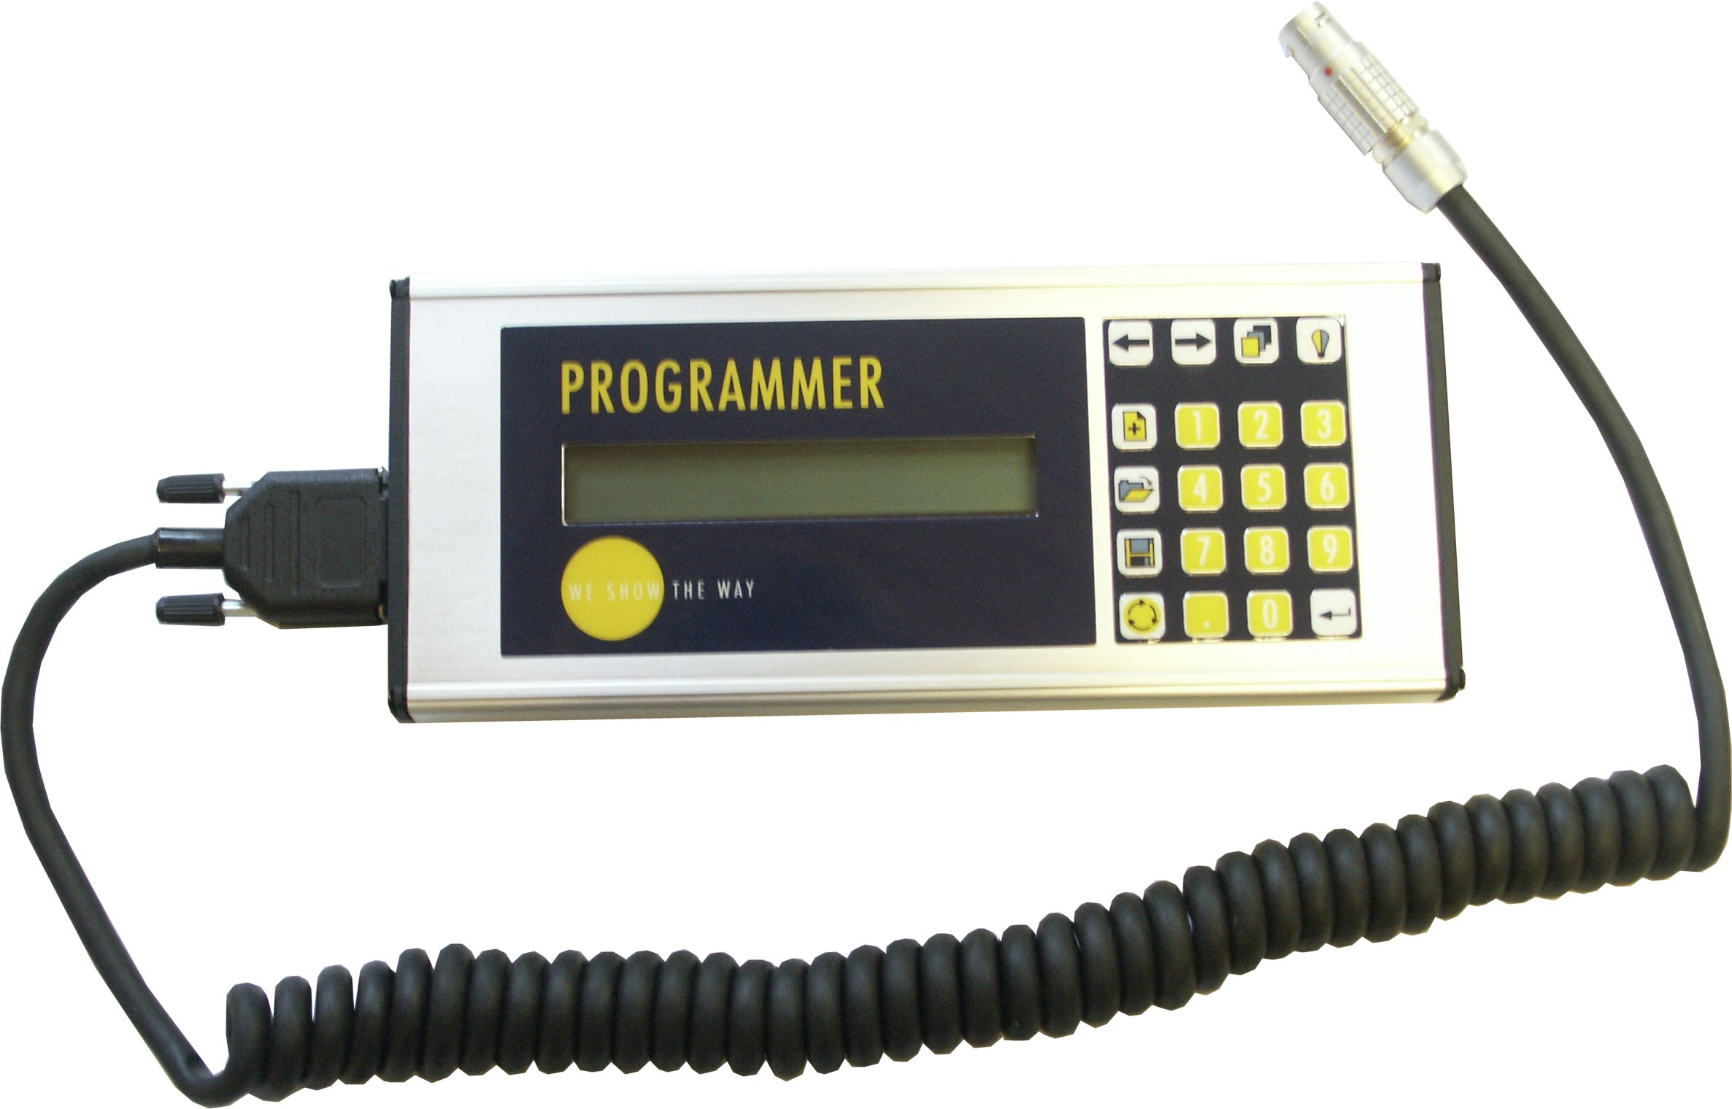

The unit is an update to the previous Programmer with the following added features
- More robust mechanical design
- Better protection against moisture
- Firmware upgrade trough serial port (FLASH memory)
- Faster serial communication (up to three times faster than the previous version)
- Automatically starts reading lantern when connected

The unit is equipped with functional and alphanumerical keys, a liquid crystal display (LCD) with two rows and a coiled wire with a quick - snap connector that fits into the lanterns.

The keys and the display are illuminated to enable night time working. The device takes its power through the connector; no external power supply is required.

MAIN FEATURES
With the Programmer you can program all the parameters in the flasher listed in chapter 6 and 7 of this manual, including:

- Lamp voltage - Threshold level
- Fixed light - Battery low voltage
- Connect filaments parallel - Battery reconnection hysteresis
- Synchronizing delay - Flashing characters

You can also monitor the analogue accumulated data in the flasher / lantern:

- Condition of filament - Battery Voltage (loaded)
- Burning time of filament - Lamp number in use
- Battery Voltage (open circuited) - Losses in connections
- Solar panel current - Panel production (Ah)

CONNECTING TO FLASHER
The Programmer is equipped with a self-latching connector (Swiss made LEMO, polished brass with gold plated connectors). The flasher is normally connected to the female standard socket when installed in a lantern or delivered as a controller in a control box.

All Sabik series of LED lanterns:
- LED 155
- MPV-LED
- VP-LED
- LED 350

comes with the data connector as standard. A pre-wired female data connector complete with IP67 proof cap can be ordered as a standard spare part to the lanterns (Sabik part code 821187).

An optional Table Top Adapter (interconnection unit to for fast programming of flasher, Sabik product code 980299) is also available when flasher is not installed inside lantern.


NOTE: The Table Top Adapter may be used only with SmartFlasher (and ProFlasher). It may not be used with the new LEDFlasher. The LEDFlasher might be damaged if it is powered up connected to the adapter due to different pin out on lantern.

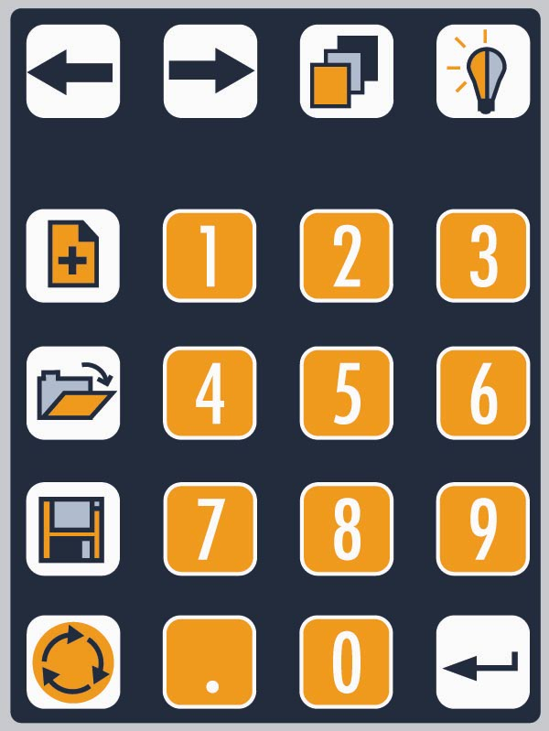
KEYS
Read
Save
Add
Move
Status/
Standard
Light
Numeric Keys
Enter
Mode
The keys arte divided into functional and numerical keys.

Key | Function
Move | Move between dialogs, shifts left or right
Add | Insert a new time pair in the middle of a character
Read | Read lantern configuration
Save | Save configuration in lantern
Status | Shifts between programmable settings and status information
Standard | Opens library of standard characters when editing character
Mode | Change between edit settings and edit characters
Light | Illuminates the keys and the display
Numeric keys | Used to enter values for settings
Enter | Initiates and confirms changes in settings

PRINCIPLES OF PROGRAM

When the Programmer is connected to the flasher, the unit starts automatically and starts reading the flasher connected immediately. Upon power up the unit will display the software version number for both the BIOS software as well as the firmware version number. When communicating with Sabik with regards to the Programmer Mk2, please state the bios / firmware revision of your unit.

After the boot message, the unit displays:

Reading Flasher data *

This may take up to 10 seconds. When the reading is done, the value of the first setting will be displayed. If no flasher is connected, or flasher communication fails the Programmer displays an error message:

COMMUNICATION FAILED
Press any key....

The user is also notified that the Programmer is now using its default values and not the ones currently in the flasher.

The Programmer automatically detects which flasher is connected and only displays the settings that are available in the flasher connected (Not Available N/A is displayed if function is not available in current flasher)

CONNECTING TO FLASHER

Depending on the flasher type connected, the Programmer will start in different modes after a read. If the flasher is a SmartFlasher or ProFlasher, then the Programmer will start automatically in Advanced Mode. If the flasher is a LEDFlasher, then the unit will automatically start in Normal Mode.

Normal Mode

When connected to a LEDFlasher, the unit will start in normal mode after the read of the flasher is ready. In normal mode, the unit will only display a limited number of the flasher settings, hiding the majority of them in order to make everyday usage a bit less complicated. By default, the unit will only display the:
- Lantern intensity (for example 100%)
- Photocell threshold level (for example 2,5V)
- Flash characters

The rest of the settings are hidden. To access the rest of the settings, the user needs to enable the advanced menus by pressing the dot key 3 times. The unit will display the “Advanced Menus” dialog for a few seconds before enabling the advanced menus.

Advanced Mode

When reading a SmartFlasher / ProFlasher or enabling the Advanced Menus from Normal Mode, the Programmer will display all flasher settings / parameters for the user.

When read of flasher is ready, the Programmer will display the first flasher setting (Parameter) in the display. Arrow keys are used to move between the various settings available in the flasher. Settings not available in the flasher is either hidden or displayed as Not Available (N/A). To enter the character settings or status information, appropriate function key has to be used. Same function key is always used both to enter and exit a set of submenus.

When at a certain parameter, you can edit and change a parameter with the Enter-key.

NOTE! Communication with flasher is not continuous. Only when Read or Save buttons are pressed communication with flasher will occur. All changes made to parameters will be updated to flasher only when the Save-key is pressed.

The Programmer operates in three modes:
- Parameter mode (flasher settings)
- Status mode (flasher monitoring)
- Character mode (editing flasher character)

The user toggles between Parameter and Character mode by pressing the Mode-key. To check the flasher status, the Status-key needs to be pressed. NOTE: The flasher status is updated only when the Programmer is reading the flasher (normally when connected). To update the values, the Read-key needs to be pressed.

EDIT PARAMETERS

In the parameter mode the user moves between the parameters with the arrow - keys. To change a value:
- toggle to the setting you want to change
- press the Enter- key (Note: by pressing it twice you interrupt the function)
- feed the new value with the numerical keys
- press the Enter- key again to accept the new values

If by mistake, you feed wrong values, you can step back using the arrow keys. In Normal mode only the most common parameters are displayed.

The parameters (system settings) for the SmartFlasher are:

FLASHER SETTINGS
1. Unit serial number
2. Lamp voltage
3. Initiate synchronizing delay
4. Fixed light
5. Connect filaments parallel
6. Minimum battery voltage
7. Reconnection voltage hysteresis
8. Lampchanger
9. Number of lamps in changer
10. Connection losses compensation
11. Photocell override (day / night / off)
12. Photocell override time-out
13. Photocell threshold level
14. Short - circuit level
15. Flashing character
16. Off period
17. Off period start date
18. Off period end date

RADIO INTERFACE SETTINGS
1. Radio ID number
2. Radio ON time (active time)
3. Radio OFF time (sleep time)
4. Radio Synchronising Mode
5. Radio Synchronising Code
6. Radio Synchronising Energy Save Mode

CHARGER SETTINGS
1. Cut-Off voltage
2. Cut-In voltage
3. Boost charge hysteresis
4. Temperature compensation


READING FROM THE FLASHER

The parameters and the analogue measurements in the flasher can be read by pressing the Read- key at any time. The programmer displays a message that reading from the flasher is in progress, and a flashing asterisk (*) is shown in the display, when information is being transferred between the units.
If the connection fails, the programmer gives an error message:

COMMUNICATION ERROR
Press any key......

The user may try again, after checking that the connections are properly fitted.

When information is transferred between the units the flasher resumes normal operations, but update on error LED flags are postponed.

The status readings are:
1. Battery voltage (under load)
2. Battery voltage (open circuit)
3. FET- switch voltage loss
4. Conductor voltage loss
5. 1. Lamp filament on- time (counter 1)
6. 2. Lamp filament on- time (counter 2)
7. Lamp number in use
8. Charging status
9. Charging current
10. Charged Ampere Hours
11. Temperature C
12. Error code
13. Flasher real time clock (SmartFlasher 2,0 or higher)


SAVING SETTINGS TO FLASHER

The parameters can be written to the flasher by pressing the WR- key in the parameter mode. Again, the programmer puts a message and the flashing asterisk into the display.

If communication fails, the Programmer will display an error message equivalent to the error message when reading flasher. However, the new settings are not verified at the flasher, so in case the user wants to verify that everything written was transferred correctly, he needs to read the parameters back to the Programmer.


EDITING FLASHING CHARACTERS

By pressing the Mode- key you toggle between time - editing and parameter mode. You also exit the flash character edit mode by pressing the Mode key again.

The first time pair is shown in the display like:

1. On: 1.00
Off: 1.00

The On- time is the time the lamp is turned on (in seconds) and the Off- time is the time the lamp is turned off (in seconds) in the first time pair. The flasher can store a maximum of 20 time pairs.


Move to the next time pair by using the arrow keys, when you get to the last one, an empty time pair is shown.

Inserting a time pair
- Find the empty time pair by pressing the right arrow key

- Press the Enter- key
- Feed in the new values
- Accept your input by pressing the Enter-key

When the time pair is accepted it is moved to the left in the display

Changing a time pair
- Find the time pair by using the arrow key
- Press the Enter- key
- Feed the new value
- Confirm by pressing Enter

Inserting a new time pair between existing time pairs
Find the time pair, in front of which you want to insert a new time pair

- Press the Add- key ( a '+'- character is shown in the left bottom of display)
- Press the Enter - key
- Feed the new time pair
- Accept by pressing the Enter- key
Exit the Add mode by pressing the Add- key once again

Deleting a time pair
Find the time pair you want to delete
- Press the dot - key
The programmer asks for your acceptance: Enter= Yes, 0 = No

Choosing a standard flashing character
A set of standard IALA flash characters (factory default) is stored in the Programmer firmware.

The default complete list of standard characters is:

CHR | LCD - DISPLAY | CHARACTER |  | Times in seconds |  |  |  |  |  |  |  |  |  |  |  |  | Tot.
Nr | NAME | Pair NR | 1 | 2 | 3 | 4 | 5 |  | 6 |  | 7 |  | 8 |  | 9 |  |  | Length
1 | Lateral | On | 0,15 |  |  |  |  |  |  |  |  |  |  |  |  |  |  | 0,15
 | ECO | Off | 2,85
2 | North mark | On | 0,15 |  |  |  |  |  |  |  |  |  |  |  |  |  |  | 0,15
 | ECO | Off | 0,45
3 | East mark | On | 0,15 | 0,15 | 0,15 |  |  |  |  |  |  |  |  |  |  |  |  | 0,45
 | ECO | Off | 0,45 | 0,45 | 3,65
4 | South mark | On | 0,15 | 0,15 | 0,15 | 0,15 | 0,15 |  | 0,15 |  | 2,00 |  |  |  |  |  |  | 2,90
 | ECO | Off | 0,45 | 0,45 | 0,45 | 0,45 | 0,45 |  | 0,45 |  | 4,40
5 | West mark | On | 0,15 | 0,15 | 0,15 | 0,15 | 0,15 |  | 0,15 |  | 0,15 |  | 0,15 |  | 0,15 |  |  | 1,35
 | ECO | Off | 0,45 | 0,45 | 0,45 | 0,45 | 0,45 |  | 0,45 |  | 0,45 |  | 0,45 |  | 5,05
6 | Special mark | On | 0,15 | 0,15 | 0,15 | 0,15 |  |  |  |  |  |  |  |  |  |  |  | 0,60
 | ECO | Off | 1,85 | 1,85 | 1,85 | 13,85
7 | Isolated danger | On | 0,30 | 0,30 |  |  |  |  |  |  |  |  |  |  |  |  |  | 0,60
 | ECO | Off | 2,00 | 7,40
8 | Safe water mark | On | 2,00 |  |  |  |  |  |  |  |  |  |  |  |  |  |  | 2,00
 | ECO | Off | 8,00
9 | Leading (lower) | On | 0,15 |  |  |  |  |  |  |  |  |  |  |  |  |  |  | 0,15
 | ECO | Off | 0,85
10 | Leading (upper) | On | 2,00 |  |  |  |  |  |  |  |  |  |  |  |  |  |  | 2,00
 | ECO | Off | 6,00
11 | Lateral | On | 0,30 |  |  |  |  |  |  |  |  |  |  |  |  |  |  | 0,30
 |  | Off | 2,70
12 | North mark | On | 0,20 |  |  |  |  |  |  |  |  |  |  |  |  |  |  | 0,20
 |  | Off | 0,40
13 | East mark | On | 0,20 | 0,20 | 0,20 |  |  |  |  |  |  |  |  |  |  |  |  | 0,60
 |  | Off | 0,40 | 0,40 | 3,60
14 | South mark | On | 0,20 | 0,20 | 0,20 | 0,20 | 0,20 |  | 0,20 |  | 2,00 |  |  |  |  |  |  | 3,20
 |  | Off | 0,40 | 0,40 | 0,40 | 0,40 | 0,40 |  | 0,40 |  | 4,40
15 | West mark | On | 0,20 | 0,20 | 0,20 | 0,20 | 0,20 |  | 0,20 |  | 0,20 |  | 0,20 |  | 0,20 |  |  | 1,80
 |  | Off | 0,40 | 0,40 | 0,40 | 0,40 | 0,40 |  | 0,40 |  | 0,40 |  | 0,40 |  | 5,00
16 | Special mark | On | 0,20 | 0,20 | 0,20 | 0,20 |  |  |  |  |  |  |  |  |  |  |  | 0,80
 |  | Off | 1,80 | 1,80 | 1,80 | 13,80
17 | Isolated danger | On | 0,30 | 0,30 |  |  |  |  |  |  |  |  |  |  |  |  |  | 0,60
 |  | Off | 2,00 | 3,40
18 | Safe water mark | On | 2,00 |  |  |  |  |  |  |  |  |  |  |  |  |  |  | 2,00
 |  | Off | 8,00
19 | Leading (lower) | On | 0,20 |  |  |  |  |  |  |  |  |  |  |  |  |  |  | 0,20
 |  | Off | 0,80
20 | Leading (upper) | On | 2,00 |  |  |  |  |  |  |  |  |  |  |  |  |  |  | 2,00
 |  | Off | 6,00

- When in Character edit mode, press Standard- key
- The list of standard character will be displayed (by name) and you can toggle through the list using arrow keys
- Select the one you want to use by pressing Enter, quit without selecting by pressing period or Standard- key


ILLUMINATION

The background illumination of the display and the keypad illumination is toggled ON / OFF by pressing the Light-key. The backlight illumination will automatically turn off when unit is idle for e certain time.

FLASHER PARAMETERS
The following is a complete list of the available settings for the SmartFlasher 6-28 and will be uploaded to the Programmer when connected (or Read key is pressed):

Flasher functions |  |  | Example | Unit
1 | Flasher serial number |  | 1234
2 | Lamp voltage |  | 28.0 | V
3 | Synchronising offset (delay) |  | 0 | S
4 | Fixed light |  | Off
5 | Connect filaments in parallel |  | Off
6 | Minimum battery voltage |  | 10.0 | V
7 | Reconnecting voltage hysteresis |  | 1,0 | V
8 | Lamp changer |  | Off
9 | Number of lamps in lampchanger |  | 0
10 | Connection losses compensation |  | Off
11 | Photocell override |  | Óff
12 | Photocell override time-out |  | 1 Day
13 | Photocell threshold level |  | 2,5 | V
14 | Short circuit level |  | 12
Timer functions |  | (seasonal lights)
15 | Off period |  | Off
16 | Off period start date |  | Jan 1
17 | Off period end date |  | June 1
Solar Charger functions
18 | Cut-off voltage |  | 14,4 | V
19 | Cut-in voltage (charging reconnecting voltage) |  | 13,8 | V
20 | Boost charge hysteresis |  | 0,5 | V
21 | Temperature compensation |  | 30 | -mV/°C

For LED lantern operation, the following settings need to be configured as below;

Nr. 2 should be set at 28V (this disables the voltage control to the output)
Nr.6 should be set at 10V (disables the light when voltage drops below 10 volts)

The other settings are more dependent on the actual operation of the lantern; but normally the light character, the solar charger settings and the photocell settings are configured individually for each site.

For complete configuration details of the SmartFlasher, please see the flasher SmartFlasher User Manual.

FLASHER READINGS

The following is a list of the available settings analogue measuring and status register of the SmartFlasher 6-28 and will be uploaded to the Programmer when connected (or Read key is pressed):

Flasher Readings |  |  | Example | Unit
1 | Battery voltage (loaded) |  | 14,1 | V
2 | Battery voltage (unloaded) |  | 14,2 | V
3 | Losses in connections |  | 0,0 | V
4 | Internal (FET) losses |  | 0,1 | V
5 | Lamp illumination time (counter 1) |  | 1251 | Hour
6 | Lamp illumination time (counter 2) |  | 0 | Hour
7 | Lamp number in use |  | 1 | Pcs
8 | Flasher Real Time Clock |  | 14.8.2003 12:34
9 | Photocell actual level |  | 1,2 | V
Charger Readings
1 | Charging status |  | Charging
2 | Solar Panel Charging current |  | 350 | mA
3 | Charged Ah’s |  | 231.0 | Ah
3 | Temperature |  | 23,1 | °C
Alarm
1 | Self Diagnostics Report |  | No Errors

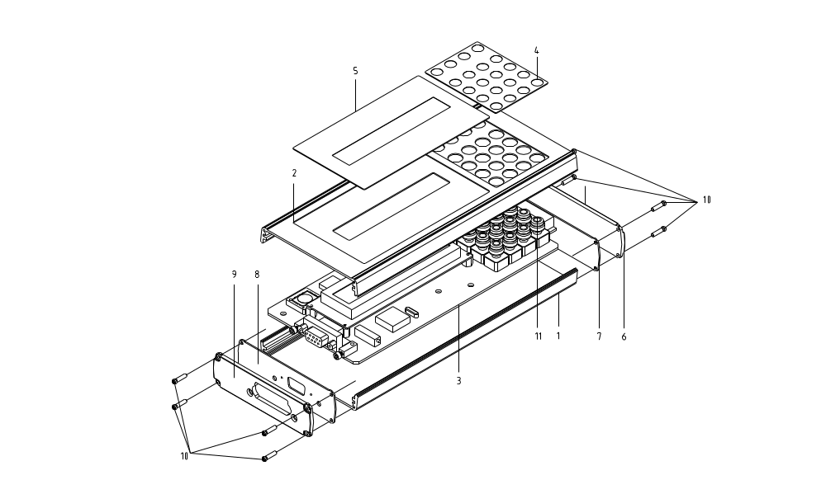

SPARE PARTS

